Azure Cost Management
- A centralized service for reporting usage and billing of Azure environment
- Self-service cost exploration capabilities
- Budgets & alerts
- Cost recommendations
- Automated exports
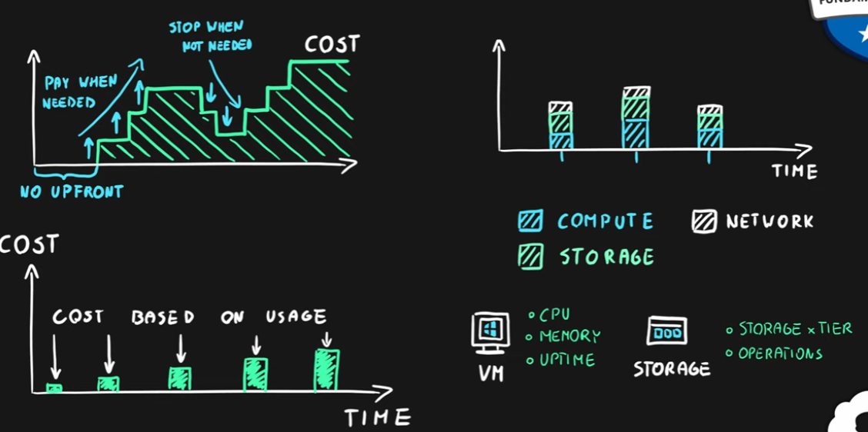
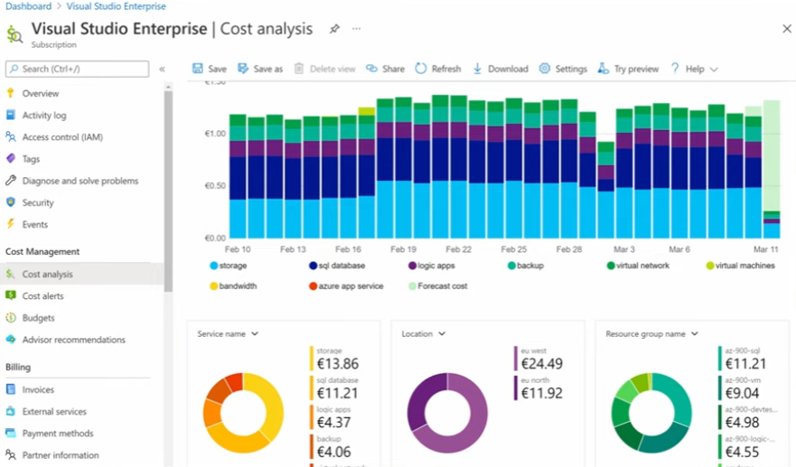

Minimizing Costs in Azure
- Azure Pricing Calculator to choose the low-cost region
  - Good latency
  - All required services are available
  - Data sovereignty/compliance requirements
- Hybrid use benefit and Azure Reservations
- Azure Cost Management monitoring, budgets, alerts and recommendations
- Understand service lifecycle and automate environments
- Use autoscaling features to your advantage
- Azure Monitor to find and scale down underutilized resources
- Use tags & policies for effective governance

